Find the months:

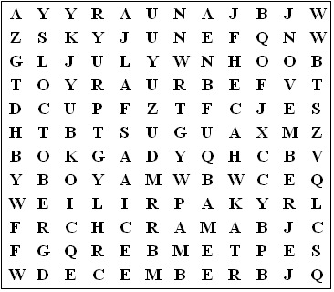

Find the days:

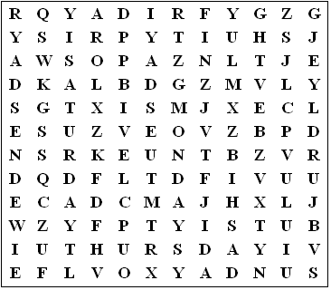
Solutions

Months

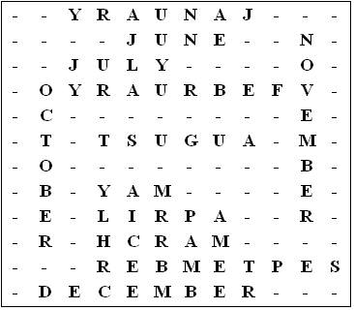

Days

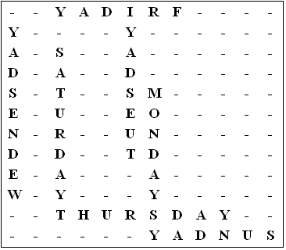

This puzzle was compiled in seconds using Toolbox.
For a free trial go to www.discoveryeducationalsoftware.co.uk/toolbox_e.htm

