Mountains of the world



Mount St Elias Kilimanjaro Mount Kenya Mount Logan Lhotse

Mount McKinley Godwin Austen Kanchen junga Citlaltepetl Puncak Jaya Matterhorn Mont Blanc MonteRosa Aconcagua Tupungato Illimani Jungfrau Everest Makalu Bonete

Mountains of the world

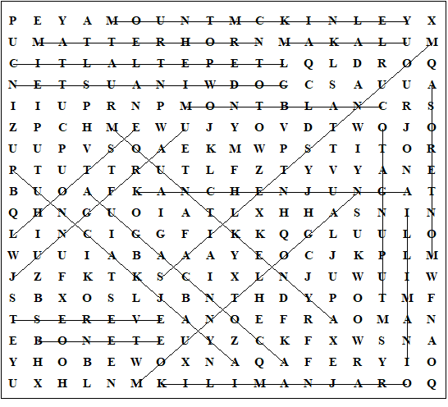

This worksheet was made up using TOOLBOX by Discovery Educational Software.

For a free trial go to www.discoveryeducationalsoftware.co.uk/toolbox_e.htm

