Mountains of the World

Beginning with the letter in the square box, follow a continuous path to find the words listed below. The trail passes through each and every letter once and may twist up, down or sideways, but never diagonally.



Dhaulagiri  Everest  Kangchenjunga  Karakoram  Kilimanjaro  Lhotse  Makalu | Matterhorn  Mont Blanc  Mount Ararat  Pichu Pichu  Puncak Jaya  Rustaveli

Mountains of the World – Solution

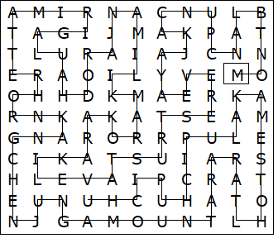

This worksheet was made up using TOOLBOX by Discovery Educational Software.

