Musical instruments

Beginning with the letter in the square box, follow a continuous path to find 19 musical instruments. The trail passes through each and every letter once and may twist up, down or sideways, but never diagonally.



Musical instruments – Solution

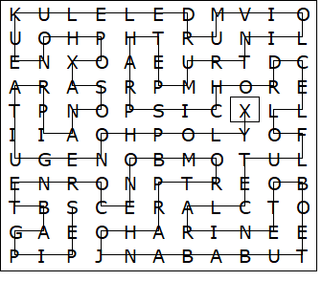

XYLOPHONE
GUITAR
PIANO
SAXOPHONE
UKULELE
DRUM
VIOLIN
TRUMPET
HARPSICHORD
CELLO
FLUTE
CLARINET
OBOE
TUBA
BANJO
HARP
TROMBONE
CORNET
BAGPIPES

This worksheet was made up using TOOLBOX by Discovery Educational Software.

