Northern Ireland

Start at the top left-hand corner. Follow the line of letters and try to make sense of it.

Write it out correctly, putting in capital letters, punctuation and spaces.

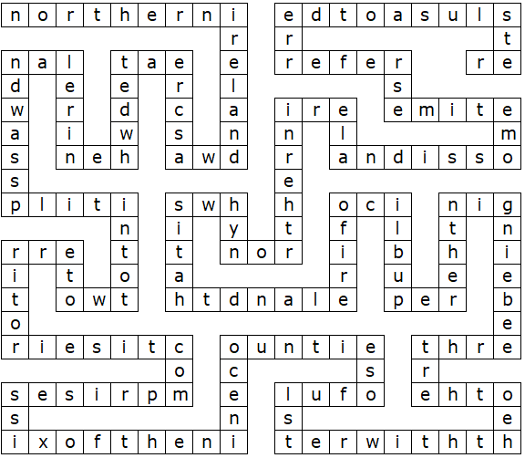
Northern Ireland (Solution)

Northern Ireland was created when Ireland was split into two territories. It comprises six of the nine counties of Ulster, with the other three being in the Republic of Ireland. That is why Northern Ireland is sometimes referred to as Ulster.

This worksheet was made up using TOOLBOX by Discovery Educational Software.

