Presidents

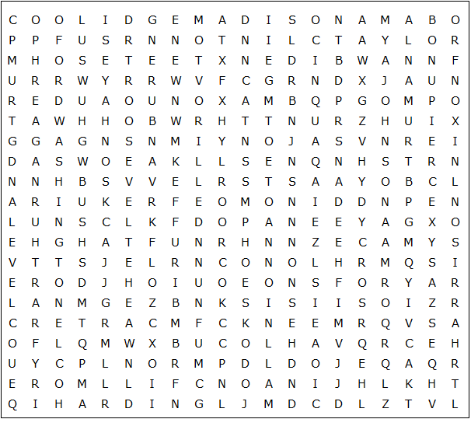

Jefferson A Johnson Buchanan Coolidge Fillmore Garfield
Nixon Obama Trump Tyler Ford Polk Taft
Harrison Harrison L Johnson McKinley Van Buren Clinton
Harding J Q Adams Jackson Kennedy Lincoln Madison Arthur
Carter G W Bush Hoover J Adams Monroe Pierce Reagan
Taylor Truman Wilson Biden G Bush Grant Hayes
F D Roosevelt Eisenhower T Roosevelt Washington Cleveland

Presidents

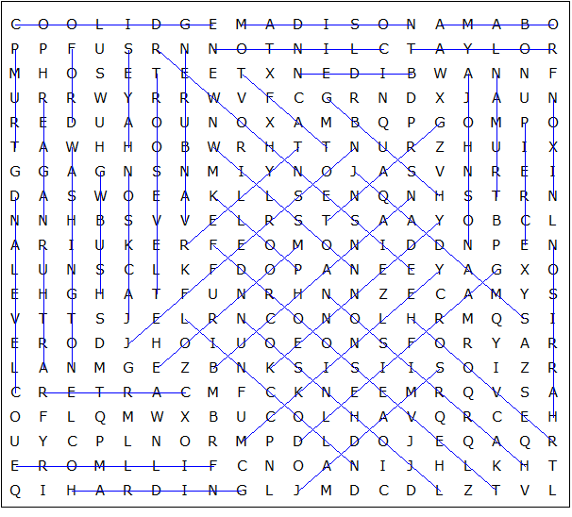

This puzzle was created in seconds using Toolbox, available for only £10 from discoveryeducationalsoftware.co.uk

