Rivers of the World

Beginning with the letter in the square box, follow a continuous path to find the words listed below. The trail passes through each and every letter once and may twist up, down or sideways, but never diagonally.

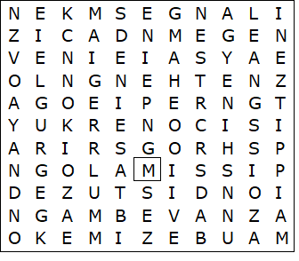

AMAZON  CONGO  DANUBE  DNIEPER  GANGES  MACKENZIE  MEKONG  MISSISSIPPI  NIGER  NILE | RHINE  RIO GRANDE  SEINE  THAMES  VISTULA  VOLGA  YANGTZE  YUKON  ZAMBEZI

Rivers of the World – Solution

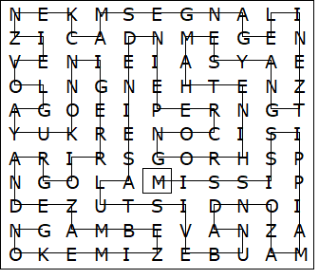

This worksheet was made up using TOOLBOX by Discovery Educational Software.

