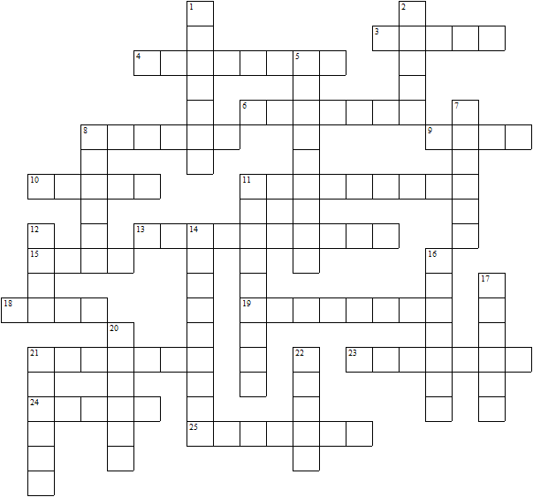
The Royal Family
Across  3 Prince William is Prince of ......  4 Andrew's elder daughter  6 Princess Anne's husband  8 The king's eldest brother  9 Prince Andrew is Duke of .....  10 Princess Anne's son  11 Prince Edward is Duke of ......  13 The palace in London  15 The king's sister  18 Princess Anne's first husband  19 The Scottish residence  21 The king's family name  23 The queen  24 Andrew's ex-wife  25 Andrew's younger daughter | Down  1 The king  2 Prince William's brother  5 Catherine is Duchess of .......  7 Edward's wife  8 Princess Anne's daughter-in-law  11 The king’s mother  12 Princess Anne's daughter  14 The future queen  16 The future king  17 The king’s father  20 The king's youngest brother  21 Prince Edward was Earl of ......  22 Prince William's mother
The Royal Family – Solution

Answers at http://www.britroyals.com/royalfamily.htm

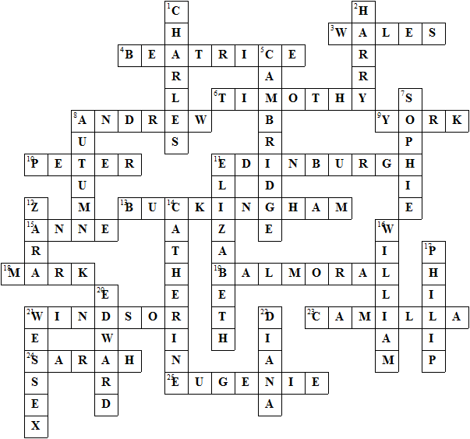

This puzzle was compiled in seconds using Toolbox.
For a free trial go to www.discoveryeducationalsoftware.co.uk/toolbox_e.htm

