Sleep

This text has been coded using numbers instead of letters.

1 = A, 2 = B, 3 = C etc.

Using the grid below will help you crack the code.

13 1 14 25 15 6 21 19 20 8 5 19 5 4 1 25 19 4 15 14' 20 7 5 20 5 14 15 21 7 8 19 12 5 5 16.

23 5 15 6 20 5 14 7 15 20 15 2 5 4 12 1 20 5 1 14 4 8 1 22 5 20 15 7 5 20 21 16 5 1 18 12 25 20 8 5 14 5 24 20 4 1 25.

2 21 20 16 5 18 8 1 16 19 23 5 19 8 15 21 12 4 3 15 21 14 20 15 21 18 19 5 12 22 5 19 12 21 3 11 25 9 6 23 5 3 1 14 1 3 20 21 1 12 12 25 6 1 12 12 1 19 12 5 5 16 23 8 5 14 23 5 7 15 20 15 2 5 4.

19 12 5 5 16 12 5 19 19 14 9 7 8 20 19 1 18 5 1 3 1 21 19 5 15 6 23 15 18 18 25 20 15 13 1 14 25 16 5 15 16 12 5.

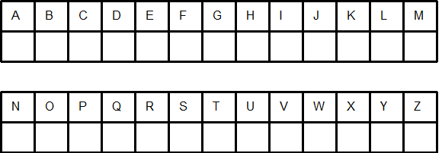
Sleep (Solution)

Many of us these days don't get enough sleep.

We often go to bed late and have to get up early the next day.

But perhaps we should count ourselves lucky if we can actually fall asleep when we go to bed.

Sleepless nights are a cause of worry to many people.

This worksheet was made up using TOOLBOX by Discovery Educational Software.

