Sports Wordsearch Plus

First find all the hidden words

Then, starting top left and working your way across each line, write down all the letters that have not been used.

The letters will spell out another five sports.

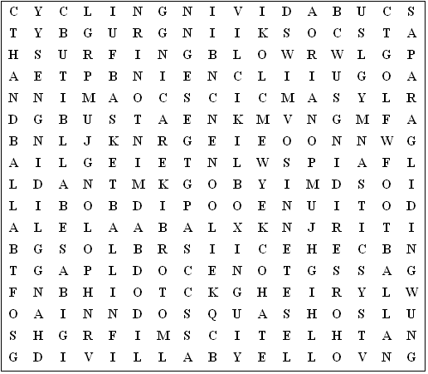

rugby golf polo motorbike racing snowboarding

hang-gliding horse-riding paragliding scuba diving

basketball gymnastics volleyball athletics squash

badminton pole vault baseball football handball tennis

high jump long jump softball swimming bowling boxing

cycling surfing cricket hockey skiing soccer
Sports Wordsearch Plus (Answer sheet)

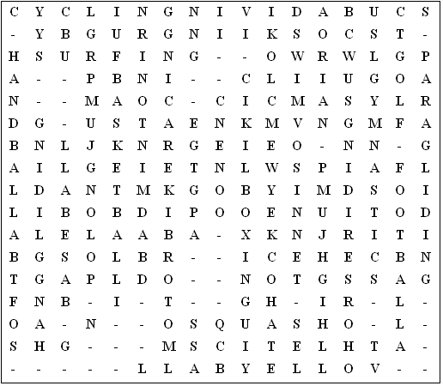

Hidden words:

table tennis, bowls, ice hockey, windsurfing, diving

This puzzle was compiled in seconds using Toolbox.
For a free trial go to www.discoveryeducationalsoftware.co.uk/toolbox_e.htm

