Stone Cold

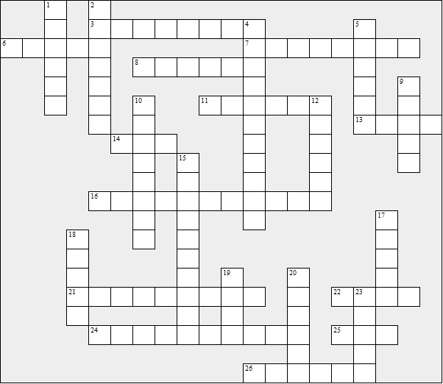

Across:  3 All of Shelter's victims were .....  6 Mother's boyfriend  7 Shelter nicknamed Link and Ginger the  ..…….. Boys  8 Got any spare .…... , mate?  11 The name of Shelter's pet  13 Link was thrown out of his rented room  because he couldn't pay the ....  14 Shelter's pet was a ....  16 Shelter hid the bodies under the ....…....  21 Link went to London soon after ....…....  22 Shelter told Ginger ..... had been knocked  down.  24 Gail's real occupation  25 Department of Social Security  26 Link's sister | Down:  1 City where most of the story takes place  2 He murdered homeless people.  4 Christmas present from Mum and sister  5 Link's homeless friend  9 Link's sister lent him ...... to go to London.  10 Link was born in ..…...  12 Daily Routine ....…... (Shelter's notebook)  15 Shelter lived at 9 .…….... Place  17 Shelter's second victim was a ....…..  18 On his first night on the London streets Link  had his .….... stolen.  19 The girl who became Link's friend  20 Before he went to London, Link sometimes  slept at his …......'s house.  23 Some unemployed people sell the Big .......

Stone Cold

Now try to find your crossword answers in the wordsearch

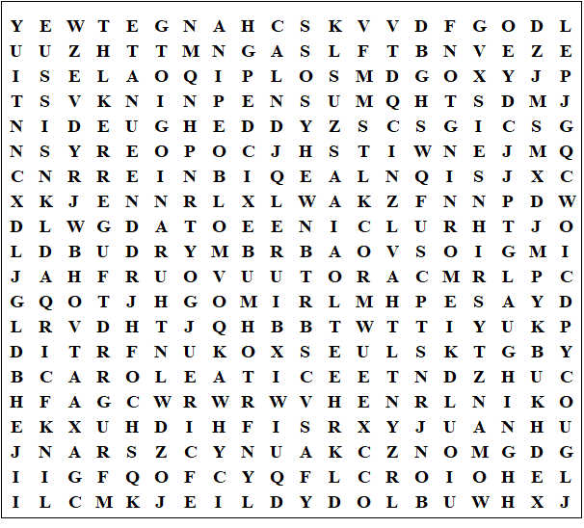

Stone Cold - Solution

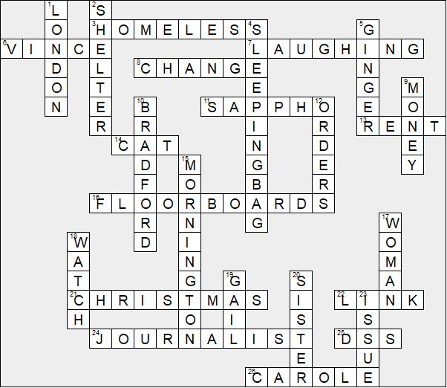

This puzzle was compiled in seconds using Toolbox.
For a free trial go to www.discoveryeducationalsoftware.co.uk
Stone Cold - Solution

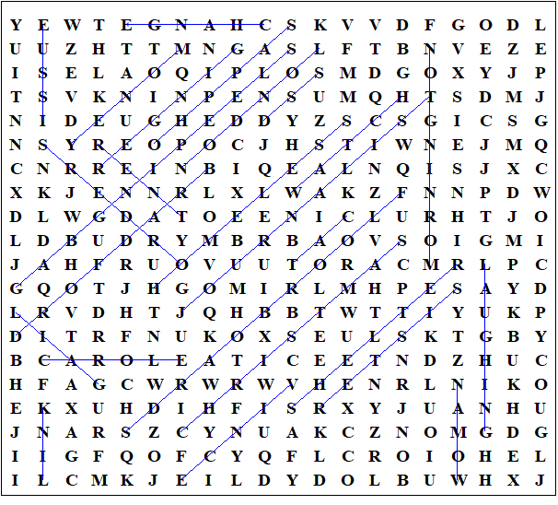

This puzzle was compiled in seconds using Toolbox.
For a free trial go to www.discoveryeducationalsoftware.co.uk

