Levi Strauss

Decode this text using the grid underneath.

Dy 1850 erv Xwodjigydw siof ghmr awm dy jhoo madys. Mi lwyp cvicov rwf liuvf ei erv wgvw dy erv ricv ij jdyfdys siof ervgv erwe ervgv awm w mrigewsv ij vuvgpfwp devlm. Ovud Megwhmm, w 20-pvwg iof dlldsgwye, ovje Yva Pigq jig Mwy Jgwyxdmxi ader w mlwoo mhccop ij fgp siifm.

Mrigeop wjevg rdm wggduwo, w siof ldyvg awyevf ei qyia arwe Megwhmm awm mvoodys. Arvy Megwhmm eiof rdl rv rwf gihsr xwyuwm ei hmv jig evyem wyf awsiy xiuvgm, erv ldyvg mwdf, 'Pih mrihof rwuv tgihsre egihmvgm!', wffdys erwe rv xihofy'e jdyf w cwdg ardxr awm eihsr vyihsr ei owme. Megwhmm dllvfdwevop rwf erv dfvw ij rwudys erv xwyuwm lwfv dyei egihmvgm.

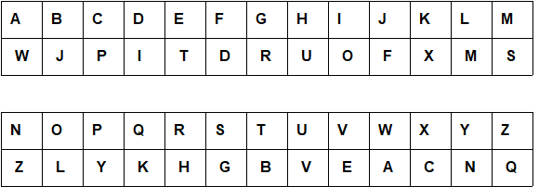
Levi Strauss (Solution)

In 1850 the California gold rush was in full swing. So many people had moved to the area in the hope of finding gold there that there was a shortage of everyday items. Levi Strauss, a 20-year old immigrant, left New York for San Francisco with a small supply of dry goods.

Shortly after his arrival, a gold miner wanted to know what Strauss was selling. When Strauss told him he had rough canvas to use for tents and wagon covers, the miner said, 'You should have brought trousers!', adding that he couldn't find a pair which was tough enough to last. Strauss immediately had the idea of having the canvas made into trousers.

This worksheet was made up using TOOLBOX by Discovery Educational Software.

