Summer Holidays

Find the words listed below the puzzle, then take all of the unused letters, left to right from the top, to find a hidden message.

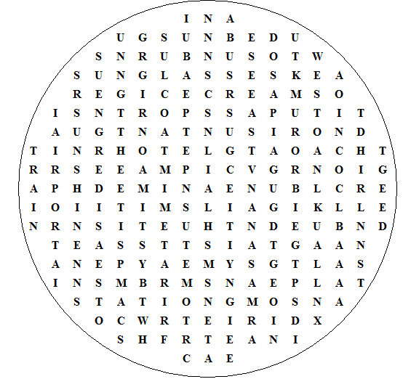

restaurant sunglasses aeroplane suitcases timetable

sunshine holidays campsite swimming ice cream

passport seaside airport sunburn luggage station

bathing tickets summer travel island suntan

sunbed hotel train disko sand taxi
Summer Holidays - Solution

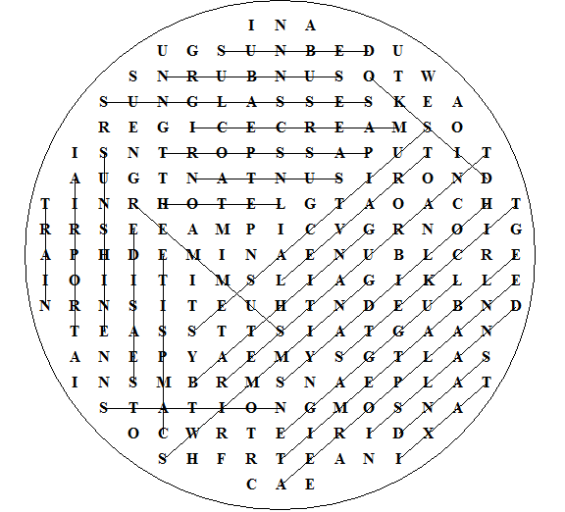

Hidden text:
In August we are going to go camping in Brittany in north France.

This puzzle was compiled in seconds using Toolbox.
For a free trial go to www.discoveryeducationalsoftware.co.uk/toolbox_e.htm (only £10 for permament use).

