UK towns and cities

Starting in the top-left-hand corner, follow the snake of letters to find 33 British towns and cities.

Each one starts with the last letter of the previous one.

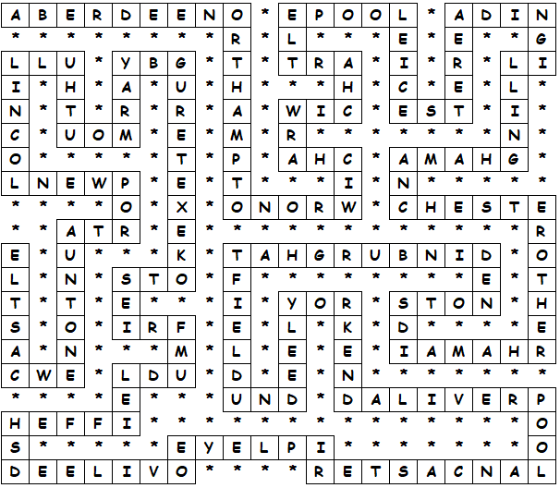

UK towns and cities

Aberdeen
Northampton
Norwich
Harwich
Hartlepool
Leicester
Reading
Gillingham
Manchester
Rotherham
Maidstone
Edinburgh
Hatfield
Dundee
Ely
York
Kendal
Liverpool
Lancaster
Ripley
Yeovil
Leeds
Sheffield
Dumfries
Stoke
Exeter
Rugby
Yarmouth
Hull
Lincoln
Newport
Taunton
Newcastle

This worksheet was made up using TOOLBOX by Discovery Educational Software.

For a free trial go to www.discoveryeducationalsoftware.co.uk/toolbox_e.htm

