UK Cities

Beginning with the letter in the square box, follow a continuous path to find the words listed below. The trail passes through each and every letter once and may twist up, down or sideways, but never diagonally.

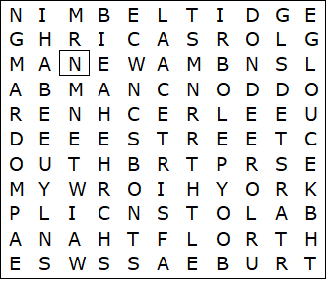

Aberdeen  Bath  Belfast  Birmingham  Bristol  Cambridge  Gloucester  Leeds  London | Manchester  Newcastle  Norwich  Perth  Plymouth  Swansea  Truro  York

UK Cities – Solution

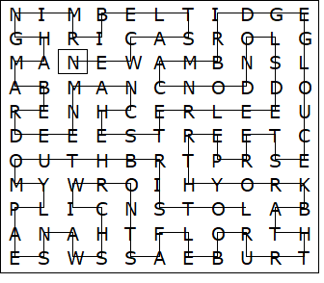

This worksheet was made up using TOOLBOX by Discovery Educational Software.

