UK English words

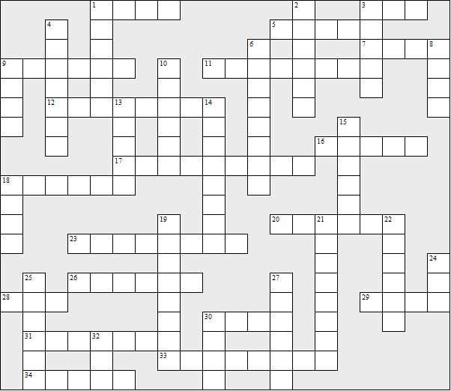

Across:  1 store  3 pitcher  5 line (people waiting)  7 elevator  9 hood (automobile)  11 soccer  12 cookies  16 truck  17 stroller  18 pantyhose  20 gas (automobile)  23 drapes  26 field hockey  28 jelly | 29 undershirt  30 movie  31 trashcan  33 sneakers  34 diaper  Down:  1 candies  2 eraser  3 jello  4 purse  6 freeway  8 cab | 9 trunk (automobile)  10 potato chips  13 fries  14 cooking pot  15 stove  18 check mark  19 sidewalk  21 pants  22 attorney  24 crib  25 yard  27 lumber  30 apartment  32 faucet
UK English words – Solution

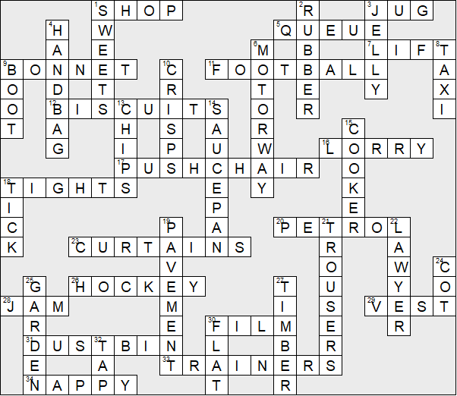

This worksheet was made up using TOOLBOX by Discovery Educational Software.

