Vegetables

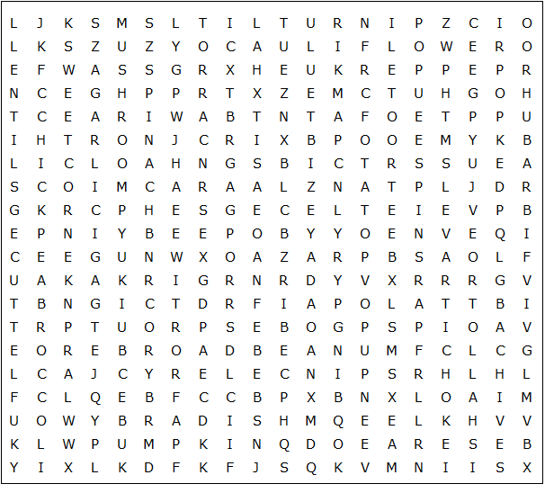

cauliflower green bean broad bean asparagus artichoke

sweetcorn beetroot mushroom broccoli chick pea soya bean

cabbage spinach lettuce parsley parsnip pumpkin rhubarb

shallot potato sprout turnip carrot radish garlic leek pea

celery pepper chives lentil onion aubergine

Vegetables – Solution

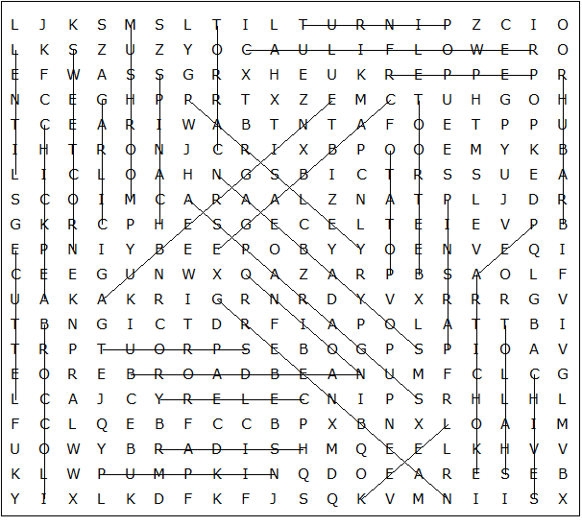

This worksheet was made up using TOOLBOX by Discovery Educational Software.

