Warner Brothers

Decode this text using the grid underneath.

Cer bjpr Mjybry Iyaceryk nk grycjnbql zbamb ca roryl gnbrpj-uary. Cer wasbtryk mryr wasy Jpryngjb iyaceryk, Ejyyl, Jqiryc, Kjpsrq jbt Djgz Mjybry. Il 1903 cerl ejt avrbrt j bngzrqatrab nb Vrbbklqojbnj. Nb 1912 cer Mjybryk irujb ca vyatsgr wnqpk nb Brm Layz Gncl. Cerl avrbrt cerny wnykc kcstna nb Eaqqlmaat nb 1918, jbt wnor lrjyk qjcry wasbtrt Mjybry Iyak. Vngcsyrk Nbg.

Rjyql nb cer 1930k cer iyaceryk vsygejkrt cer Kcjbqrl Ga., ambry aw 250 gnbrpjk, jbt Wnykc Bjcnabjq Vngcsyrk, mnce esur kcstnak nb Isyijbz, Gjqnwaybnj.

Nb 1989, cer gapvjbl jbbasbgrt cerl mryr ca pryur mnce Cnpr Nbg., jqceasue nc caaz cma lrjyk way cer pryury ca cjzr vqjgr. Acery pryuryk nb cer waqqamnbu lrjyk yrksqcrt nb cer waypjcnab nb 2018 aw cer vyrkrbc ayujbnkjcnab, Mjybry Prtnj QQG.

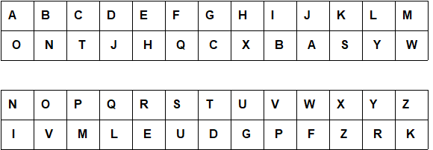
Warner Brothers (Solution)

The name Warner Brothers is certainly known to every cinema-goer. The founders were four American brothers, Harry, Albert, Samuel and Jack Warner. By 1903 they had opened a nickelodeon in Pennsylvania. In 1912 the Warners began to produce films in New York City. They opened their first studio in Hollywood in 1918, and five years later founded Warner Bros. Pictures Inc.

Early in the 1930s the brothers purchased the Stanley Co., owner of 250 cinemas, and First National Pictures, with huge studios in Burbank, California.

In 1989, the company announced they were to merge with Time Inc., although it took two years for the merger to take place. Other mergers in the following years resulted in the formation in 2018 of the present organisation, Warner Media LLC.

This worksheet was made up using TOOLBOX by Discovery Educational Software.

