Weather Wordsearch Plus

First find all the weather words in the puzzle.

Then, starting top left and working your way across each line, write down all the letters that have not been used.

The letters will spell out a secret messsage.

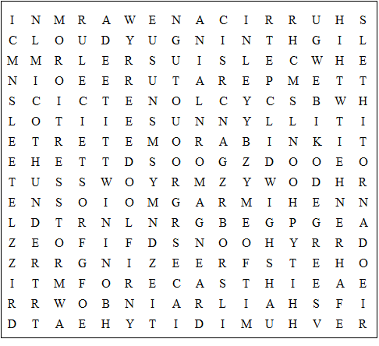

temperature thermometer Fahrenheit barometer sleet storm

humidity Celsius cyclone degrees drizzle rainbow warm

ice thunder tornado typhoon isobars cloudy flood

foggy frost cold hail heat snow hurricane lightning

blizzard forecast freezing sunny windy
Weather Wordsearch Plus

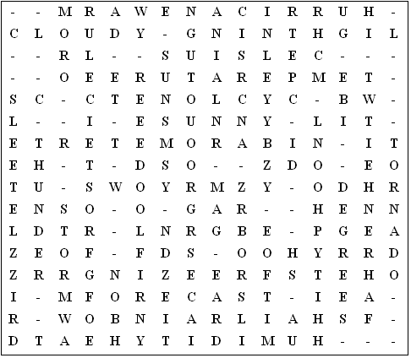

Secret messsage:

In summer when it is hot I like to go swimming in the river.

This worksheet was made up using TOOLBOX by Discovery Educational Software.

For a free trial go to www.discoveryeducationalsoftware.co.uk/toolbox_e.htm

