Who sang that song? (Teens)



Across:  1 Take Me To Church  6 All Of Me  7 Passionfruit  9 Shotgun  12 Counting Stars  13 Touch  15 Gangman Style  18 Best Song Ever  21 Hey Brother  22 Don't Call Me Up  23 Thinking Of Me  24 Let It Go  25 I'm Sexy And I Know It  26 Chandelier  27 Get Lucky  28 Hold Back The River | Down:  2 Your Song  3 Empire State Of Mind  4 Set Fire To The Rain  5 Castle On The Hill  8 Chasing The Sun  10 Paradise  11 Love Yourself  14 Wrecking Ball  16 Can't Feel My Face  17 Diamonds  19 Roar  20 Born This Way
Who sang that song? (Teens) – Solution

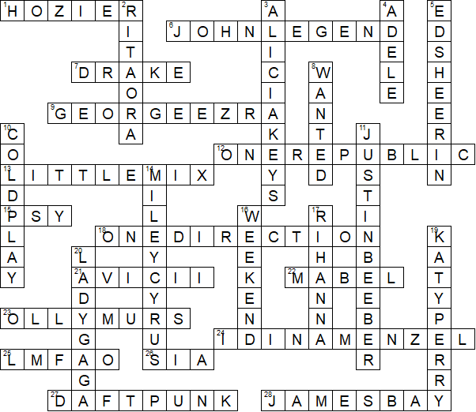

This worksheet was made up using TOOLBOX by Discovery Educational Software.

