Who sang that song? (Sixties)

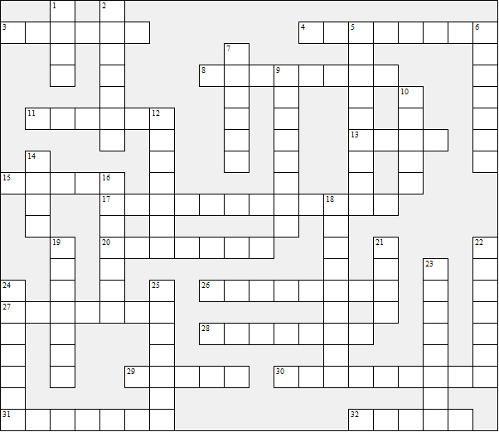

Across:  3 I Can't Get No Satisfaction (Rolling .....)  4 Delilah  8 Save The Last Dance For Me  11 I Remember You (Frank .....)  13 Shout  15 Sunny Afternoon  17 Good Luck Charm  20 My Way (Frank .....)  26 The Times They Are A-Changin'  27 Oh, Pretty Woman (Roy .....)  28 Happy Together  29 Things (Bobby .....)  30 Barbara Ann  31 The Carnival Is Over  32 Mr. Tambourine Man | Down:  1 Flowers In The Rain  2 Day Tripper  5 Ob-La-Di, Ob-La-Da  6 Foot tapper  7 Wild Thing  9 You've Got Your Troubles  10 You're My World (..... Black)  12 Mellow Yellow  14 Runaround Sue  16 Rag Doll (Four .....)  18 Let's Turkey Trot  19 She's Not There  21 Do Wah Diddy Diddy (Manfred .....)  22 I'm Into Something Good (Herman's  .....)  23 Lily The Pink  24 Bus Stop  25 House Of The Rising Sun
Who sang that song? (Sixties) – Solution

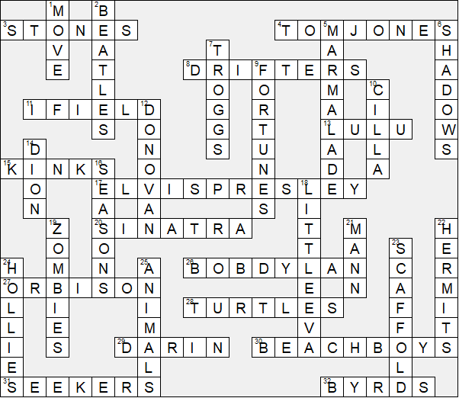

This worksheet was made up using TOOLBOX by Discovery Educational Software.

