Who sang that song? (Seventies)

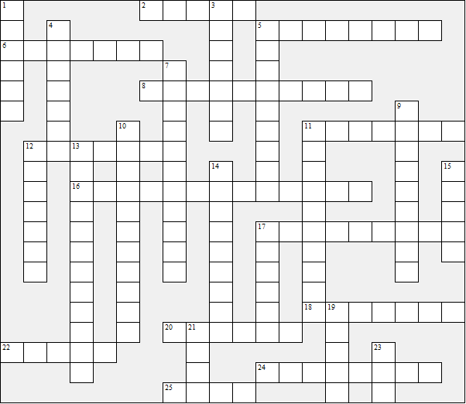

Across:  2 Mull Of Kintyre  5 Sugar Baby Love  6 Without You  8 Tonight's The Night  11 If You Leave Me Now  12 Stayin' Alive  16 Y.M.C.A.  17 Another Brick In The Wall  18 Up The Junction  20 Hotel California  22 Blockbuster  24 Wuthering Heights  25 Tie A Yellow Ribbon | Down:  1 Rasputin  3 Follow You Follow Me  4 Heart Of Glass  5 Wishing On A Star  7 December 63  9 Don't Give Up On Us  10 Sweet Caroline  11 Yesterday Once More  12 Yes Sir, I Can Boogie  13 The Wonder Of You  14 You To Me Are Everything  15 Cum On Feel The Noize  17 Message In A Bottle  19 We Will Rock You  21 Chiquitita  23 Tiger Feet
Who sang that song? (Seventies) – Solution

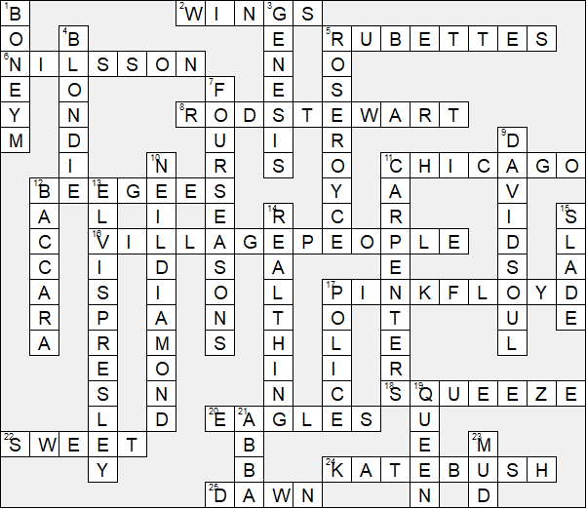

This worksheet was made up using TOOLBOX by Discovery Educational Software.

