Who sang that song? (Eighties)

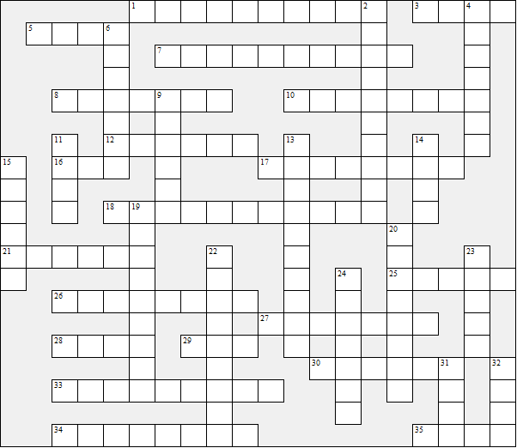

Across:  1 China Girl  3 Lay All Your Love On Me  5 Wake Me Up Before You Go-Go  7 Brass In Pocket  8 The Tide Is High  10 Tainted Love  12 I'm In The Mood For Dancing  16 Take On Me  17 Eye Of The Tiger  18 Walk Of Life  21 1999  25 Don't Turn Around  26 Rain Or Shine  27 House Of Fun  28 99 Red Balloons  29 A Town Called Malice  30 Every Breath You Take  33 Down Under | 34 Running Up That Hill  35 Drive  Down:  2 Sweet Dreams Are Made Of This  4 Eternal Flame  6 La Isla Bonita  9 Mirror Mirror  11 Your Love Is King  13 Wild Boys  14 Africa  15 The Final Countdown  19 Fame  20 Nothing's Gonna Stop Us Now  22 Chain Reaction  23 Only You  24 Livin' on a prayer  31 Orinoco Flow  32 I Owe You Nothing
Who sang that song? (Eighties) – Solution

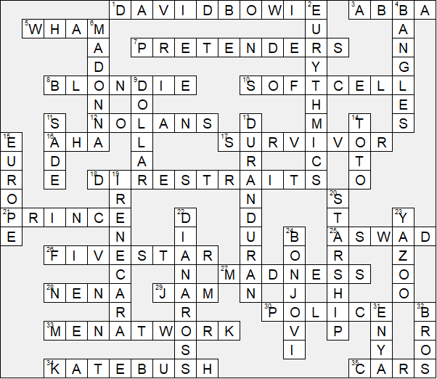

This worksheet was made up using TOOLBOX by Discovery Educational Software.

