Who sang that song? (Nineties)

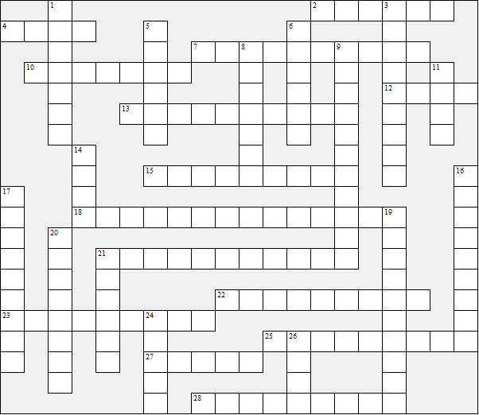

Across:  2 Mmm Bop  4 Kiss From A Rose  7 Brimful Of Asha  10 MamboNo5  12 Common People  13 My Heart Will Go On  15 Love Is All Around  18 Let me entertain you  21 Livin' La Vida Loca  22 Fairground  23 Can You Feel The Love Tonight  25 Dance The Night Away  27 Tragedy  28 Never Ever | Down:  1 Vogue  3 Wind of change  5 Killing Me Softly  6 Take My Breath Away  8 It Must Have Been Love  9 Man! I Feel Like A Woman!  11 Country House  14 Walking In Memphis  16 Young At Heart  17 Saturday Night  19 Wannabe  20 A Million Love Songs  21 Cotton Eye Joe  24 Don't Look Back In Anger  26 Barbie Girl
Who sang that song? (Nineties) – Solution

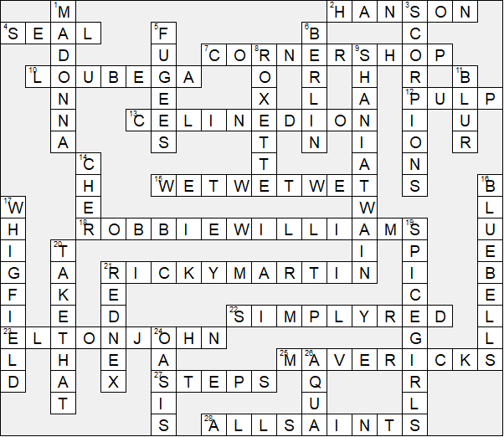

This worksheet was made up using TOOLBOX by Discovery Educational Software.

