Woodwork Wordsearch Plus

First find all the words in the puzzle.

Then, starting top left and working your way across each line, write down all the letters that have not been used.

The letters will spell out a secret messsage.

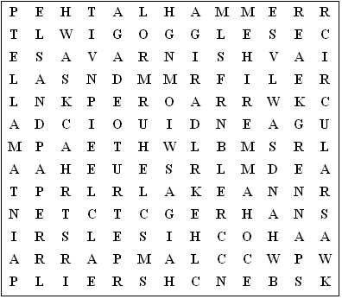

circularsaw sandpaper workshop spanner hacksaw file

handsaw varnish goggles hammer router hammer pliers

mallet chisel bench brace clamp drill plane lathe

paint glue screwdriver
Woodwork Wordsearch Plus (Answer sheet)

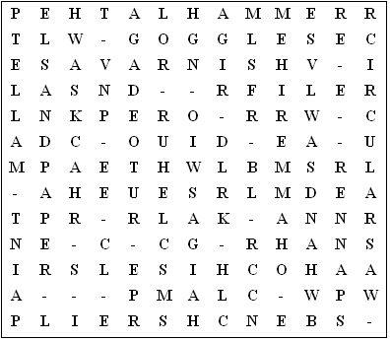

Secret messsage:

I am making a letter rack.

This puzzle was compiled in seconds using Toolbox.
For a free trial go to www.discoveryeducationalsoftware.co.uk/toolbox_e.htm

