Cities of the World

Beginning with the letter in the square box, follow a continuous path to find the words listed below. The trail passes through each and every letter once and may twist up, down or sideways, but never diagonally.

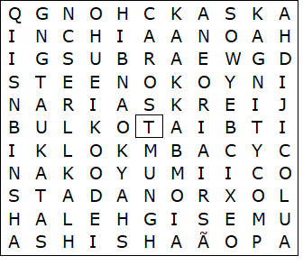

BEIJING  BUENOS AIRES  CAIRO  CHONGQING  DELHI  DHAKA  ISTANBUL  KARACHI  KINSHASA | KOLKATA  MEXICO CITY  MUMBAI  NEW YORK  OSAKA  SÃO PAULO  SHANGHAI  TOKYO

Cities of the World – Solution

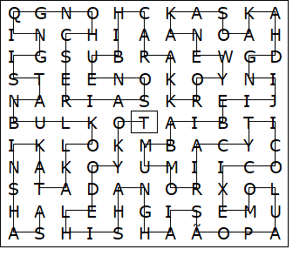

This worksheet was made up using TOOLBOX by Discovery Educational Software.

