The city of York

There are two versions of this worksheet.

The first requires the student to work out what the text says.

The second gives the student the text.
The city of York

Starting at the top left-hand corner, follow a continuous path to read about the city of York. The path goes left, right, up and down, but not diagonally. Each letter is used only once.

Write it out correctly, putting in spaces and punctuation.

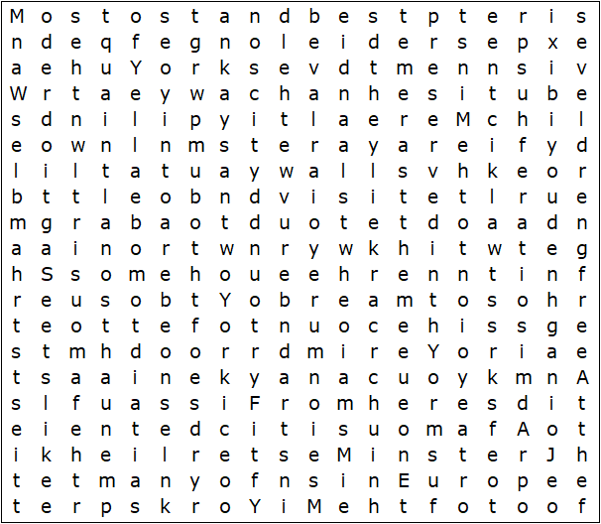

The city of York

Starting at the top left-hand corner, follow a continuous path to find the following text. The path goes left, right, up and down, but not diagonally. Each letter is used only once.

Most of York's city walls are medieval, and they are the longest and best preserved in the country. From here you can admire York's famous Minster. Admission to the Minster is expensive, but children get in free. At the foot of the Minster lie many of York's prettiest streets, like the famous Shambles. Wander down the quaint little alleyways, and visit the market where you're bound to bump into a bargain or two. York is said to be one of the most haunted cities in Europe. Join a ghost walk, if you dare.

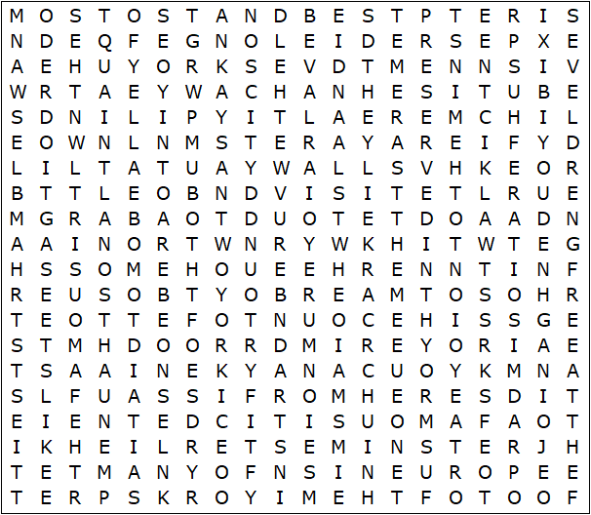
The city of York – Solution

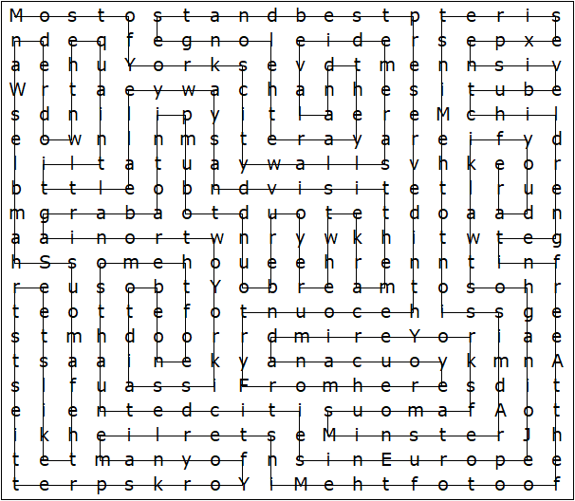

Most of York's city walls are medieval, and they are the longest and best preserved in the country. From here you can admire York's famous Minster. Admission to the Minster is expensive, but children get in free. At the foot of the Minster lie many of York's prettiest streets, like the famous Shambles. Wander down the quaint little alleyways, and visit the market where you're bound to bump into a bargain or two. York is said to be one of the most haunted cities in Europe. Join a ghost walk, if you dare.

This worksheet was made up using TOOLBOX by Discovery Educational Software.

