Zodiac signs

First find all the zodiac signs in the puzzle.

Then, starting top left and working your way across each line, write down all the letters that have not been used.

The letters will spell out a secret messsage.

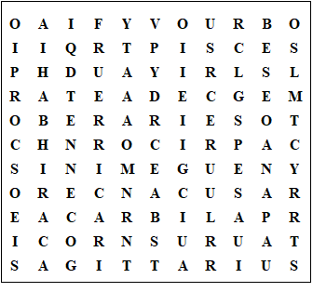

Aquarius
Pisces
Aries
Taurus
Gemini
Cancer
Leo
Virgo
Libra
Scorpio
Sagittarius
Capricorn
Zodiac signs

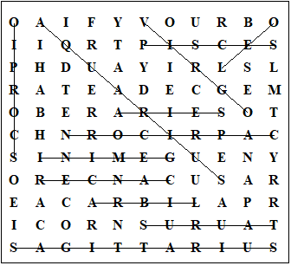

If your birthday is late December, then you are a capricorn.

This worksheet was made up using TOOLBOX by Discovery Educational Software.

For a free trial go to www.discoveryeducationalsoftware.co.uk/toolbox_e.htm

