Zodiac Wordsearch Plus

First find the twelve signs of the zodiac

Then, starting top left and working your way across each line, write down all the letters that have not been used.

The letters will spell out a secret messsage.

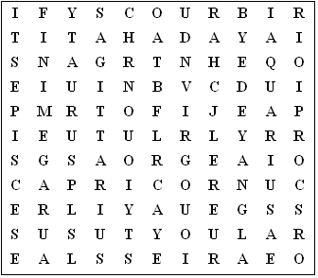

The zodiac signs are:

Aquarius Aries Cancer Capricorn Gemini Leo
Libra Pisces Sagittarius Scorpio Taurus Virgo

Zodiac Wordsearch Plus (Answer sheet)

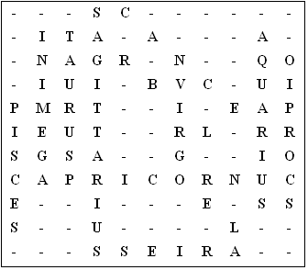

Secret messsage:

If your birthday is the end of July or early August you are a Leo.

This puzzle was compiled in seconds using Toolbox.
For a free trial go to www.discoveryeducationalsoftware.co.uk/toolbox_e.htm

