Zoo animals

1 Find the 15 zoo animals hidden in the puzzle

2 Going from left to right, starting with the top row, write down all the letters which have not been used, to find four more zoo animals.

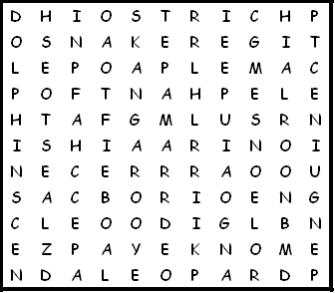

elephant kangaroo ostrich giraffe leopard

camel snake lion bear seal

penguin dolphin monkey zebra tiger

1 ………………………………………………… 3 …………………………………………………
2 ………………………………………………… 4 …………………………………………………
Zoo animals - solution

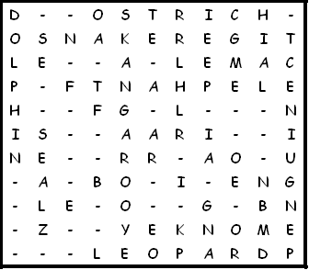

- hippopotamus
- rhinoceros
- crocodile
- panda

This puzzle was compiled in seconds using Toolbox.
For a free trial go to www.discoveryeducationalsoftware.co.uk/toolbox_e.htm

